BIT/2024//73820
Week 9 Documentation

Device features
GPS tracking was added to Shredded Squad app through the dependencies, geolocator and sensor plus, to track user activity routes for accuracy in calorie tracking.
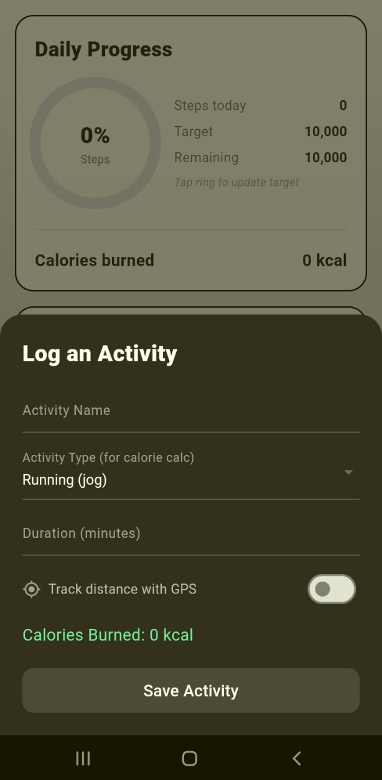

The GPS needs user permission to access user’s device location for it to accurately function.
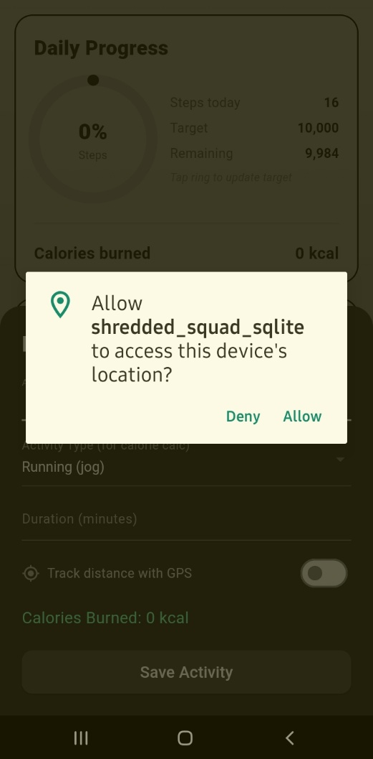

Users are also required to give the app permission to access the camera and the images stored locally as the camera function is added in the app.
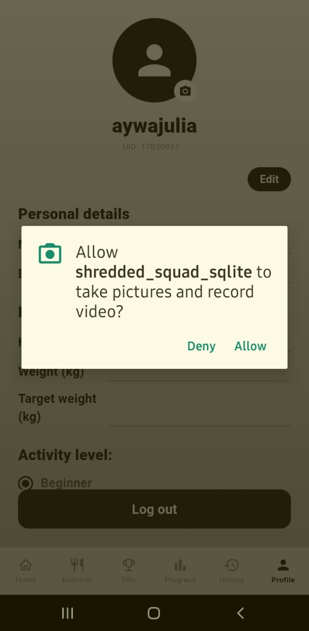

The app stores the image locally onto your profile:
